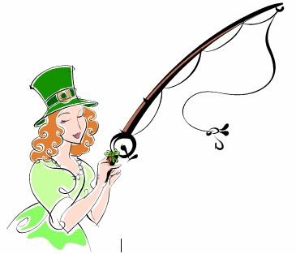

Women’s Surf Fishing Club of New Jersey
March News Letter 2014
Spring is just not getting here fast enough this year--------------------<*{{{><
Hello Ladies,
At February’s meeting We got to meet and welcome a few new members to the club.
Dorothy Obropa
Sue Leonard
Donna Alexander
Welcome ladies. We hope to have you in the suds fishing next to us as soon as this winter decides to give us a break.
A Few of the items covered at Our meeting where..
- Salt water registry Number must be into the secretary by March 1st. You will not be eligible to fish tournaments or enter affidavits without providing your reg #.
- WSFC has 3 registered Team with ASAC. For the 2014 tournament season.
- There is now a $5.00 fee per angler to offset bait cost per fishing tournament.
- There will be a $5.00 cancelation fee for any angler Not showing up after being assigned to a team. Without 48 hours’ notice. $5.00 fee will be waved for emergency cancelations t/b/d/ or if the spot is filled by another angler.
Beach conditions:
ASAC has again asked the participants in the tournaments to be mindful of what we do on the beach….WATCH your speed 15mph limits on all beaches, Please clean up after the tournament take with you ALL trash, Bait may go IN the ocean, or taken with you. DO not dump on the beach. AND again there is a reminder about going in the water past waist high while fishing a tournament. EVEN when crossing through a slew.
Reported from Island Beach State park there is a fenced off area near the Jetty. DO Not under any circumstances try to get past this barricade. It is federal monitored for the repair of the area from the hurricane. Encroachment could jeopardize losing more of the beach.
OUR awards Banquet is nearly here APRIL 5th. YOU MUST get your money in to Andrea for the banquet by March 22. We must provide the links with a head count 2 weeks prior to the event…there will be no money taken at the door…. However we are looking forward to some “entertainment” and of course the celebration of our women that have had many great fishing achievements this year. The final tournament schedule is out. There will be signup sheets at the Banquet to start filling in our teams for this season.
Speaking of awards a HUGE congratulations to Arlene and Susan for their ASAC awards this year.
Arlene took both 3rd places in Largest & Most Women.
Susy took 1st place Most fish Women. And got her first Jacket.
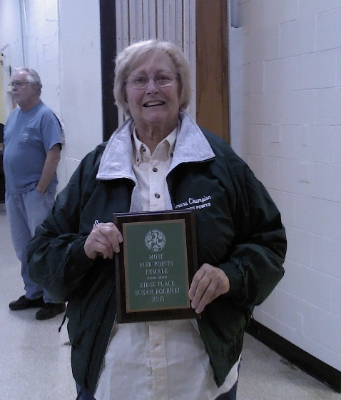
Way to go ladies you make us So proud!!!!
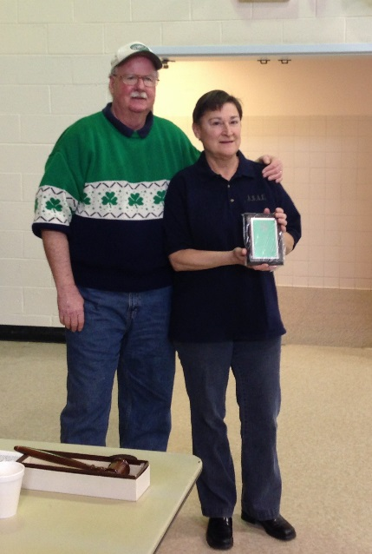

Finally a reminder that our tournament is scheduled for Sept.20th not too early to keep your eyes out for sales and stuff for the raffle table.
Also on March 29th at LBI club in Harvey cedars there will be a meeting about tournaments, rules, and all the issues that happen when the judges don’t know what they are doing. Everyone is welcome to go. Maybe you can learn, maybe you can teach. Starts with coffee and donuts at 9:00 am. These are good informative meetings, good chance to learn more about being a judge.
OH I am so itchin’ to be fishin’----------------------<*{{{><
Tight lines ladies see you all on April 5th at the banquet.
Chris
Pres. WSFC of NJ.Inc.

