Spring Forward Ladies,
What a great meeting we had on the 2^{nd.} It was really nice to see such a great turn out.

WSFC Welcomes New Member, Stephanie Pumarejo!

We are very excited about our new web site. If you haven’t had the chance to browse around, please take a look. http://wsfcnj.org
When you go into the link, Pictures and Videos, please note that they are set up in categories. We will continue to add categories such as Tournaments, 2013, Banquet, WSFC Tournament, etc. So keep your cameras and smart phones ready this year. Shoot pictures and send your pix to Andrea so they can be compiled and added to our site in groups.

If you have not registered to fish in New Jersey, you MUST do so before getting a line wet. We voted at the meeting to have everyone verify their registration by sending a copy of your card into the club by sending it to Andrea – seanote13@aol.com

Once I printed mine out, I shot a photo with my phone and sent it to Andrea
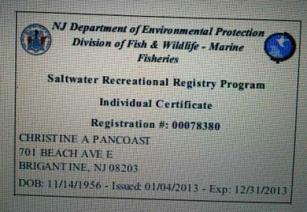
Here is the link for renewals or 1st time applicants.
www.saltwaterregistry.nj.gov
If you can’t send a picture of your card, then send in your registration number and expiration date. Please comply so we know we are all legal before the tournaments starts. Unregistered anglers cannot be part of our affidavit program nor can they fish ASAC tournaments. If an angler is asked to produce their registration card and doesn’t have one, the whole team could be disqualified and sanctions could be leveled against the club…this is important and it is the law.
Lisa Simmons, our very own yard sale queen, has volunteered to head up our yard sale fund raiser planned for this summer. She is currently researching the best date based on other activities on Brigantine Island As soon as the date is set; we’ll get it out to you. In the meantime, start collecting your stuff as your doing your spring cleaning. Remember that one person’s junk is another person’s treasure!
A few of you are already planning on tying some rigs to sell. THAT’S A GREAT IDEA! We will print out labels that can be put on the baggies proclaiming, “HAND TIED BY THE WOMEN OF WSFC”. We will add our web address on the labels for those who want to learn more about us after catching fish on our rigs.

It’s 2012 Awards Banquet time. The first place awards go to . . . Ha ha. That’s all I’m saying.
The competition was very close this year. The Awards Banquet is the night we find out, so please join us to celebrate our accomplishments!
PLEASE REMEMBER - Your money and reservations for the Awards Banquet must be in by March 23rd. Head count to the Brigantine Links has to be finalized 2 weeks in advance. If you have any questions, call or email Andrea (seanote13@aol.com) or Arlene (aperkowski@yahoo.com). They have put together a very nice evening for us.

Ladies, The Association of Surf Angling Clubs' annual meeting for the year 2013 will be held Saturday, March 16th at the Intermediate School in Ocean City, NJ, located at 18th St. and Bay Ave. Coffee and donuts will be served at 9:00 AM, with the general meeting beginning promptly at 10:00 AM. Lunch will be served. Each club is allowed three delegates plus those from our club who will be receiving awards. If you have any interest in joining us that day, please call me.
Sharon, Jane J, and I will be getting awards. Neither WSFC A or B teams placed in the top 5 this year, nor did we win the cup.

I know we are gearing up for wins this year!
We’ll see you all at the banquet
Tight lines and strong knots----------------<*{{{><
Chris

